HR ANALYTICS SYSTEM
(Employee Attrition & Performance Analysis Using Python, SQL & Tableu)
Prepared By:
Afifah Khatoon

TOOLS USED:
- Python (Pandas, NumPy, Matplotlib, Seaborn)
- SQL (basic queries)
- Tableu (Dashboard creation)
- Jupyter Notebook
- CSV / Excel dataset
ACKNOWLEDGEMENT:
I would like to express my gratitude to all online learning platforms, documentation, and resources that helped me complete this HR Analytics project.
This project helped me understand real-world data analysis using Python, SQL, and Tableu.

OBJECTIVE:
The objective of this project is to analyze employee data to:
- Understand employee attrition patterns
- Identify key reasons for employee resignation
- Analyze performance factors affecting productivity
- Build interactive dashboards using Tableu
- Practice real-world data analytics workflow

Dataset Description:
Employee Table
Emp_ID | Age | Gender | Department | Salary | Attrition
101 | 29 | Male | IT | 50000 | Yes
102 | 35 | Female | HR | 60000 | No

Performance Table

Emp_ID | Performance_Score | Overtime
101 | 70 | Yes
102 | 85 | No

Attendance Table

Emp_ID | Working_Days | Present_Days
101 | 30 | 25
102 | 30 | 29

Project Workflow

- Import datasets in Python
- Data cleaning and preprocessing
- Merge all tables using Emp_ID
- Perform Exploratory Data Analysis (EDA)
- Calculate KPIs (Attrition rate, attendance %, etc.)
- Perform SQL queries for insights
- Build Tableu dashboard
- Generate final report

Python Implementation:

- Dataset Description

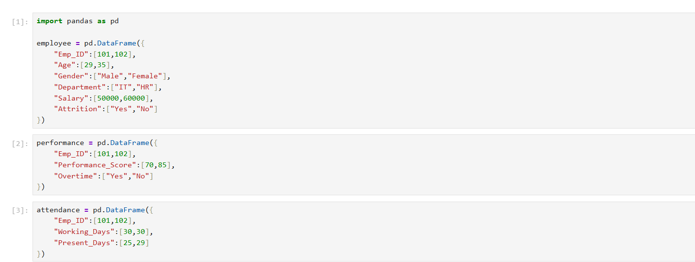

- Data merging

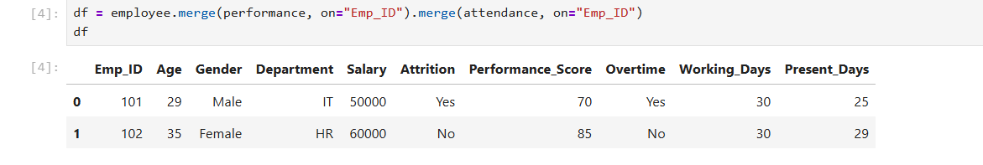

3.Attendance Percentage Calculation

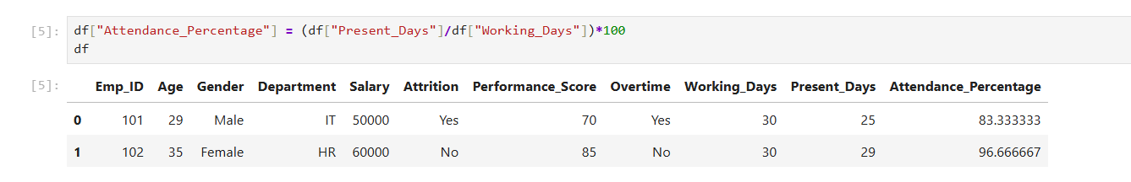

4.Department
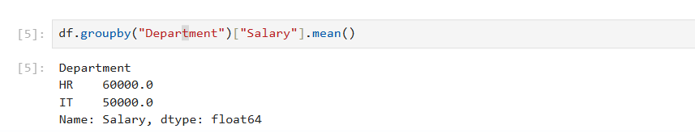
5.Attrition Count Analysis

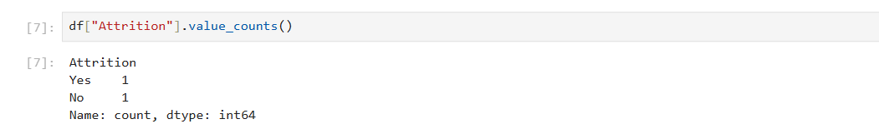
6.Employee Attendance Analysis
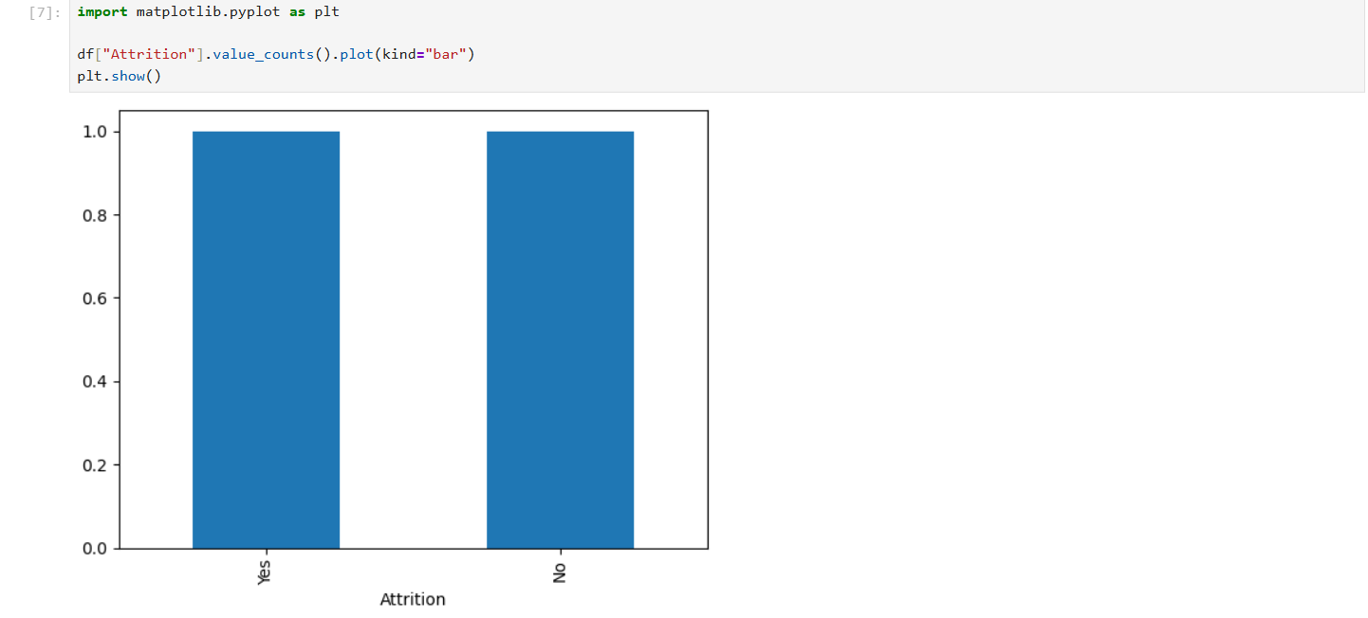

Key Metrics / KPIs
Attendance Percentage
$$Attendance Percentage=\frac{Present Days}{Working Days}×100$$

Attrition Rate
$$Attrition Rate=\frac{Employees Left}{Total Employees}×100$$

SQL Implementation:-

1: Create Employee Table
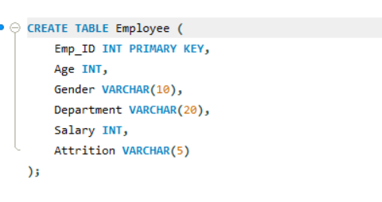
2: Insert Data

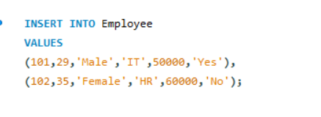
3: Create Performance Table
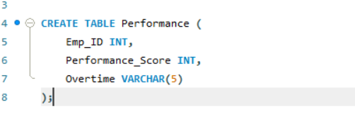
4: Create Attendance Table
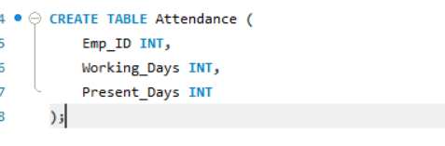
5: Employee Data Integration Using JOIN
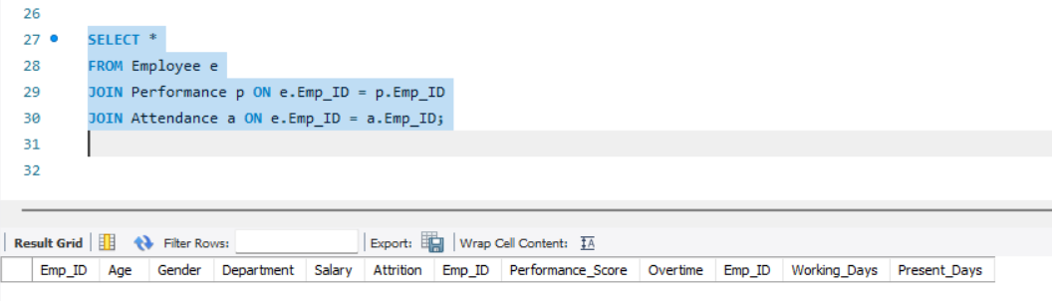
6: Department-wise Average Salary Analysis

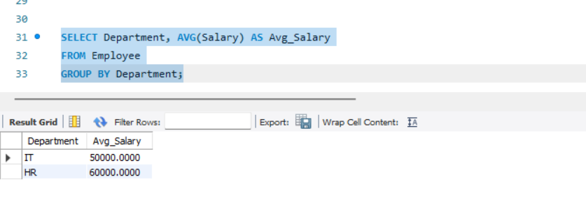

7: Employee Attrition Analysis

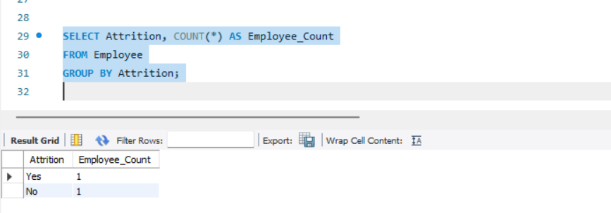

Tableau Dashboard:-
Description:
A Tableau dashboard was created to visualize employee attrition, salary, attendance, and performance metrics. The dashboard provides a quick overview of key HR insights.

Department-wise Average Salary:-

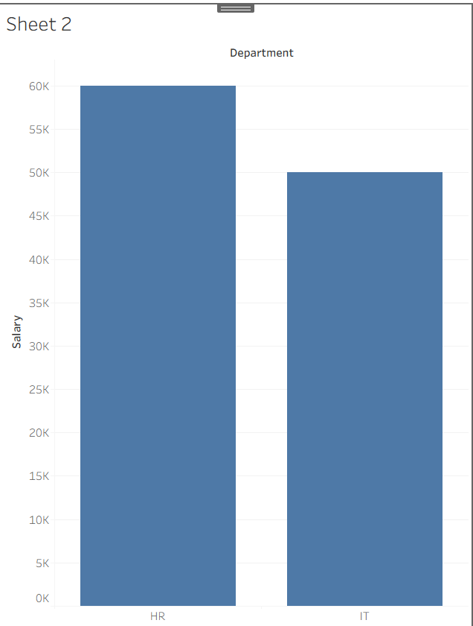

Attendance Percentage Analysis:-

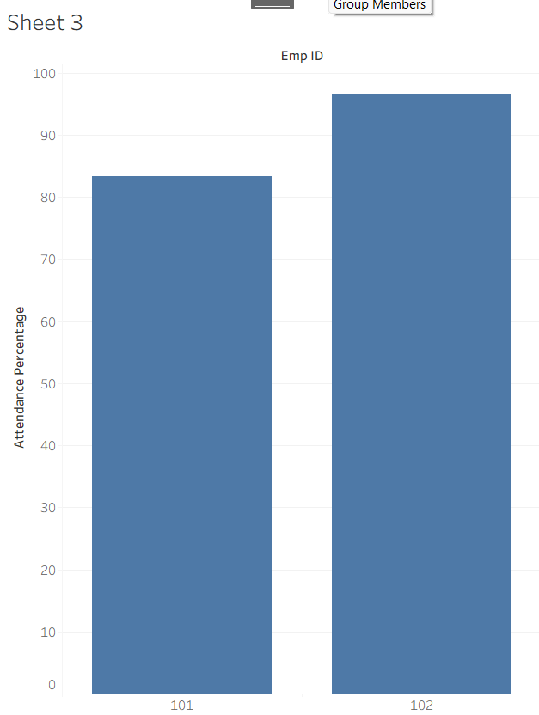
Performance Score Analysis:-

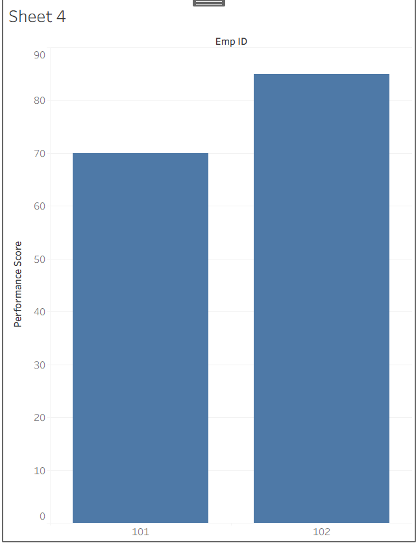

Conclusion:-
This HR Analytics project used Python, SQL, and Tableau to analyze employee attendance, performance, salary, and attrition data. The analysis provided useful insights and demonstrated skills in data cleaning, data analysis, SQL queries, and dashboard creation. Overall, the project shows how data analytics can support better HR decision-making.

Thank you,

